Niran N.S  Contact:niranns007@gmail.com Mobile:+91-9741564357 |  | 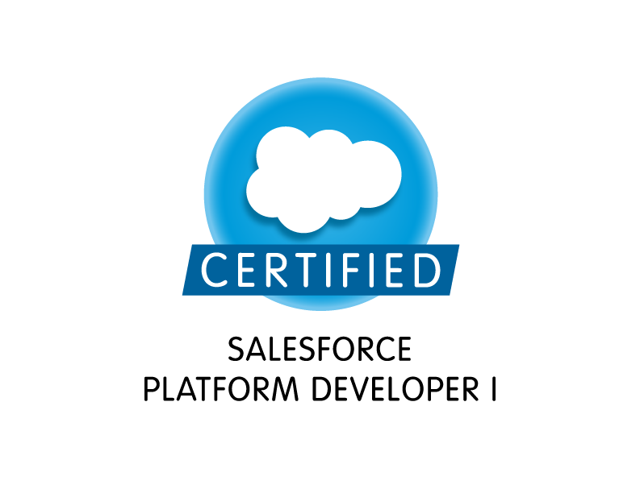

Total Experience:7.2Yrs

Experience Summary

- Highly focused and diligent Certified Salesforce Developer with 3.8 yrs. experience in design, development and customizations.
- Excellent onsite experience in working at client site (Singapore) 3 yrs. by taking the entire ownership of the project from requirements gathering phase till deployment phase.
- Good knowledge and work experience in Apex programming – Triggers, Classes, Workflow Rules, Web-services, Security Access, and Process Builder, Schema Builder, Governor Limits, Visual Force Pages.
- Strong implementation experience using custom objects, approvals, workflow rules, Apex Classes.
- Good knowledge on using Developer Console, Writing Test Class and execution.
- Proficient in using meta-data migration tools like Eclipse IDE and Salesforce Apex Data Loader.
- Strong knowledge on writing SOQL, SOSL queries.
- Configured and implemented single sign on in salesforce.
- Salesforce Web Service Integration with .Net applications for both SOAP and REST services.
- Implementation experience in Username-Password Oath authentication flow.
- Functional Domain experience includes Publishing, HealthCare, and Education.
- Expertise in Microsoft Technologies for 7+ yrs. C#, Asp.net.
- Expertise in working and adopting projects involving Agile Methodology.
- Experience in developing Web based Applications using ASP.NET, AJAX, C#, ADO.NET, and SQL Server 2005/2008.
- Good knowledge and experience in using Ektron Content Management System, Telerik Rad Controls for rich User Interface.
- Was involved in Database development with extensive use of DML/DDL statements for Sub-queries, Joins, Stored Procedures, Jobs, Functions, and Triggers using SQL Server 2005/2008.
- Expertise in working with ADO.NET Components such as Dataset, DataTable, DataAdapter and DataReader.
- Highly motivated with excellent interpersonal and communication skills, which will contribute to the success of the organization. Has the ability to work independently and in a team.
- Managed and designed website independently using Ektron cms.
- Experience in dealing with Linq to Sql , Entity Frameworks.

Technical Skills
Platform Salesforce, .NET

Sales Force Skill Set Triggers, Classes, Workflow Rules, Web-services, Security Access, and Process Builder, Schema Builder, Governor Limits, Visual Force Pages

Technologies: .NET Framework 1.x/2.0/3.5/4.0/4.5 C#, ASP.NET, ADO.NET, ASP, HTML, XML, JavaScript, WCF, Ektron(CMS), CSS,Ajax, Jquery.

RDBMS: MS SQL Server 2005/ 2008

Programming Languages: C, C++, Apex, C#.NET 2.0/3.0/4.0/4.5 LINQ

Versioning Tools: Team Foundation Server (TFS)

Operating Systems: Windows XP, Window Server 2003, MS-DOS

Others: BMC Remedy

IDE: Eclipse, Visual Studio

Education

Bachelors of Technology in Information Technology
Percentage of Marks: 68.9%
Mahatma Gandhi University
Adi Shankara Institute of Engineering and Technology
Kalady- Kerala
India

School: Bhavans Vidya Mandir, Girinagar
Board: C.B.S.E , 12th
Percentage of Marks : 77%

School: Bhavan’s Vidya Mandir, Girinagar
Board: C.B.S.E, 10th
Percentage of Marks : 75%

Contact
Phone: +91-9741564375
E-Mail: niranns007@gmail.com
Address: M1/9,”Kannaki”, Indira Nagar, Kadavanthara, Kochi-682020

Professional Experience
Achievements:
- Certified Salesforce Developer : ( CERTIFICATION NUMBER: 8551872)
- Best Client Appreciations received for Onsite and offshore Projects Handled.
- Awarded Wipro Winner Points for client appreciations and client management.

Wipro Ltd
Senior Software Engineer Nov ‘2012 –Current’

Onsite Projects: Singapore

Project: Author Solutions (Penguin Group)
Author Solutions is a leading book publishing company. It is the leading provider of self-publishing and book marketing services for authors around the globe. There are 13 brands under this industry and each brand is managed as a different website.
The author can choose any of the available brands to publish his/her book. Author is also free to buy the available services and packages from the website which helps to construct and publish the book.

Responsibilities:
- Part of project and architectural analysis.
- Developed Lead management and affiliate management project using Salesforce Technology using Apex classes, web-service, .net integration-salesforce integration, workflows.
- The Lead Management project involves submission of Lead details from .net platform to Salesforce platform by exposing apex classes as web service to .net platform.
This helps the creation/tracking of leads in salesforce and possible conversions from lead to contacts.
- Affiliate management involves .net integration with salesforce, workflow automation, custom object, email templates wherein interested users can host the banners of the publishing brands.
Dealt with security configuration.
- Designed and developed Free Lancer module in which all the content writers belonging to a distance less than 10 miles would be listed down for author to choose.This was implemented using GeoLocation service provided by Google using REST services.
- Configured SSO settings in salesforce.
- Developed SOQL and SOSL queries to get data from different related objects.
- Developed rich user interface and ektron templates using Ektron CMS for the website.
- Involved in Requirement Analysis phase and feasibility analysis.
- Independently developed a tool for deployment process using TFS API.
- Created efficient stored procedures in SQL Server.
- Used ADO.NET for data retrieving, querying and storage of data.
- Has integrated Post Code service so that the registration process of the Authors is speeded up and the mailing addresses are accurate. This ensured reliability in the book publishing workflow.
- Ensuring the quality of the deliverables. Unit testing & System Integration Testing for application.
- Is responsible for developing an email workflow of all the websites. This would handle the emails for purchase orders of all the available brands.
- Responsible for independently fixing issues with Payment method subsystem related to the website.
- Used 3-tier, n-tier architecture for presentation layer, business-layer and data-access layers.
- Developed and automated the tax workflow through which the authors can manage their tax filings through the website.

Environment:
Salesforce, C#.NET, ADO.NET, ASP.NET 2.0/3.5, Web Forms, SQL Server 2005 and 2008, IIS, Java script, Windows Server 2003, Visual Studio 2008 and 2010, XML, Html, Commerce Server 2007,Ajax, BiztalkServer 2009, SalesForce, LINQ, Jquery, WCF, TFS API, Microsot Outlook interop, Ektron CMS.

Team Size: 10
Project: Republic Polytechnic (Educational System)

RP is a govt. aided educational institution which uses the automated educational system.
Process from attendance of the student to publishing the student’s grade is automated in RP.

Responsibilities:

- Gather requirements from clients and propose feasible solutions for the salesforce application Vendor Management System.
- Provide efforts estimation and provide a detailed plan of subtasks to the client.
- Played the role of salesforce consultant, Designed and implemented workflow rules, triggers and approvals for the application.
- Taken complete ownership of change requests from requirements gathering till Deployment phase.
- Design, Develop modules to augment the education system to cater to new business needs.
- Worked directly with the client to formulate solutions.
- Configured the Salesforce.com environment.
- Created email templates, approval processes, approval page layouts and defined approval actions on them to automate the processes.
- Created Custom Profiles, Public Groups and Roles to distribute user rights and functionality.
- Worked as Ektron content management consultant for the managing content of Republic Polytechnic Singapore.

Environment:
Salesforce, Asp C#.net, MSsql 2008, Linq to Sql, Ektron Content Management System.

Offshore Projects:

Project: CISCO (Supply Chain Management)
Team Size: 20
Period: 1 year

ION is a Website for managing supply chain management of Cisco.
Comprises of different modules which in turn has different projects which handles each component in supply chain management of Cisco.
E.g. Administration module handles ION user statistics, usage trend, cumulative users etc.
PDMAT handles production delivery metrics calculation

Responsibilities:
- Responsible for development, support, maintenance and implementation of a relatively complex project module.
- Works on problems of complex scope, through extensive usage of standard concepts & principles.
- Proposing and developing solutions to address the business needs.
- Has the ability to respond to detailed queries.
- Applies own judgment to independently determine a course of action, which is then executed independently post review.
- Responsible for coaching, and mentoring junior members in the team.
Created SSIS package for extracting information from table to .Csv file and email to the user using scheduled job.
- Designed and developed an ETL validation system that validates the data for scheduled Jobs in the system.
- Designed and developed a web analytics system for cisco supply chain management to keep track of user clicks and website usage.

Environment
.Net Mvc, MSql 2008, SSIS , ETL operations

Suyati Technologies Sep ‘2010 – Nov 2012’
Software Developer

Project: Comet Portal (Health Care)
Team Size: 10

- Deals with managing .opening and budget allocation of medical booths.
- Involves designing and developing an approval workflow for submitter, vendor, approver, certifier for a budget plan and its associated exhibits.

Responsibilities
- Page designing, Database design.
- Hold daily meetings with manager and client.
- Writing stored procedures, assisting team members for coding and database related tasks.

Environment
Asp.Net ,C#, MSSql 2008

Project: Kewaunee Scientific Corporation (Health Care)
Team Size: 4

Responsibilities
- Develop an all in one website for the company.
- Set up project meetings and gather requirements from the team Manager.
- Project task estimation and feasibility study.
- Analyse the extend of possible Ektron CMS customization.
- Research and bring up the best possible solutions provided by Ektron CMS.
- Reduce the developer involvement in the website.
- Make the website completely customizable for the business analyst.
- Least or no developer interference for content management of the website.
- Designing rich user interface web pages

Environment:
Visual Studio .NET 2010, Ektron Cms 8.6, xml, css, html.

Ektron Expertise:
- Worked extensively with different versions of ektron like 7.5, 8.0.0128, 8.5.
- Dealt with creating and designing page-wire templates.
- Developed and designed custom widgets.
- Worked on different customizations of Ektron controls.

Orion India Systems Pvt. Ltd Aug‘2009 – Sep’2010
Software Engineer
Projects Involved: Vector 2009, eAudIT 2008, 2009, 2010
KPMG is a leading Auditing company which ranks in top 4 companies worldwide. The project is to develop an auditing tool based on company’s auditing standards. This project is developed to support Desktop versions. And the application is developed on master-client architecture. Features like Tasks, Issue-Tracker, Remote Packages, Close-Out, Roll Forward, and Document Management makes eAudIT a very powerful tool for auditing.

Responsibilities:
- Involved in various stages and versions of the Application
- Involved in requirements, analysis and support of various version of the Application
- Involved in Business meeting to discuss technical limitations and suggested few alternate design options.
- Involved in developing a tool to support the support team.
- Written various Stored Procedures using SQL to automate the regularly performed task(s) like to get Entity/Attribute details for a particular screen.
- Responsible for writing SQL Queries/ Stored Procedures to retrieve data from different entities and display in a custom format.
- Extensively used sqlCmd for Database operations on QA Environment.
- Responsible for Debugging the application for critical issues using the debugging tools provided by the Visual Studio.Net IDE.
- Used ADO.NET objects DataSet and DataAdapter to have consistent access to SQL Server 2008.
- Tracking, Assigning and closing the tickets created by Auditors in BMC Remedy.
- Taking up training sessions during every new release of eAudIT .
- Worked as shift Lead and has managed team comprising of 5-6 members.
- Independently developed a tool for the support team to handle issue tracker issues.
- BizTalk Administration and development.

Environment:
Visual Studio .NET 2008, MS Office 2007, Windows 7, BMC Remedy

Environment:
Visual Studio .NET 2010, Ektron Cms 8.6, xml, css, html.

References available on request

